Mandilla S. (Leeper) Fryback
October 14, 1859 – April 29, 1947

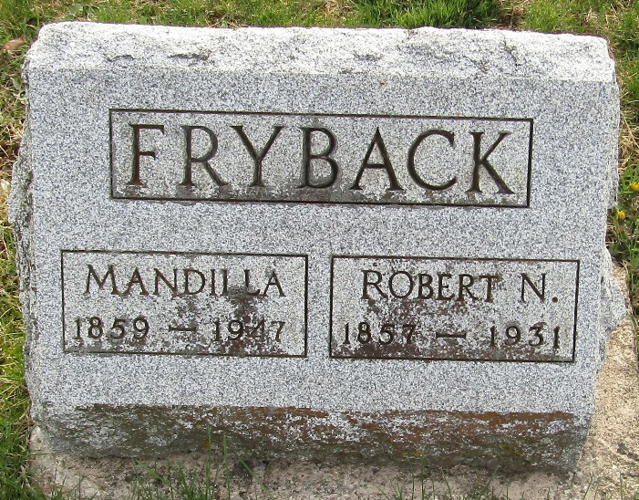

Maudilla S Fryback
in the Indiana, U.S., Death Certificates, 1899-2017
Name Mandilla S Fryback
[Mandilla S Leeper]
Gender Female
Race White
Marital Status Widowed
Age 87
Birth Date 14 Oct 1859
Birth Place Wells Co Indiana
Death Date 29 Apr 1947
Death Place Bluffton, Wells, Indiana, USA
Death Registration Date 1947
Father Jacob Leeper
Mother Elizabeth Nelson
Spouse Robert Fryback
Informant Mrs. Charles Porter; Uniondale, Indiana
Burial May 1, 1947; Murray Cemetery

