John Henry Fryback
1862 – February 8, 1919

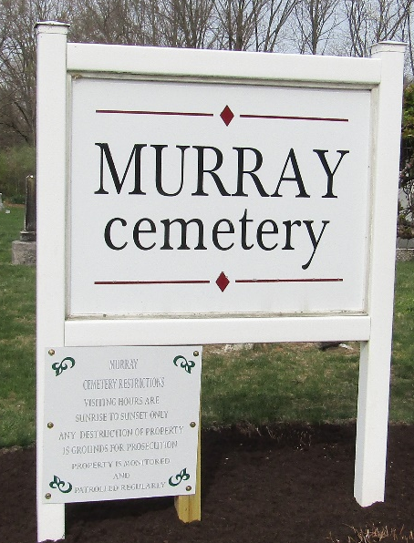

Mrs. J. Fryback Found Husband Dead In Home
Death from Attack of Heart Trouble During Wife’s Short Absence

The sudden death this forenoon at about ten o’clock of John Henry Fryback, living in the second home east of the Myers Green House, came as a great shock to relatives and those who knew him. Mrs. Fryback stated that he had been feeling poorly for the last two weeks, but no physician had been called to diagnose his case through he had taken some medicine the last few days prescribed by a doctor. Last night he passed in restless times but this morning was apparently feeling better and dressed.
About ten o’clock, Mrs. Fryback came up town to purchase some groceries and left her husband sitting in a chair by the window smoking a pipe. When she returned, she noticed his absence and when she entered the house found him reclining on the couch dead. Coroner Thoma was immediately called to take charge of the body. It is thought his death was due to an attack of heart trouble.
The deceased was a son of Lewis & Elizabeth Fryback and was born sixty-four years ago on the home place one mile north of Uniondale. Here he spent his boyhood and has been a continuous resident of Wells County.
Sixteen years ago he was united in marriage to Mrs. Mary Wysong and four years ago they moved to Bluffton to reside. There were no children born to this union.
Besides leaving the widow and two children by his second wife, Merrill Fryback of Chicago, and Mrs. Hallie Hart of Indianapolis, he is survived by three brothers, Robert of Uniondale; Joshua of Frankfort and Frank Fryback of Bluffton.
The funeral will be held at ten o’clock Monday forenoon at Murray.

Bluffton Evening News, Wells County, Indiana
February 8, 1919

**
Indiana, U.S., Death Certificates, 1899-2017
Name John Henry Fryback
Gender Male
Race White
Marital Status Married
Age 57
Birth Date 1862
Birth Place Wells County, Indiana
Death Date 8 Feb 1919
Death Place Lancaster, Wells, Indiana, USA
Death Registration Date 1919
Father James Fryback
Mother Elizabeth Hart
Spouse Wysong
Informant Mrs. J. H. Fryback; Bluffton, Indiana
Burial February 10, 1919; Zion Cemetery (sic)

