George T. Fryback
June 9, 1790 – July 30, 1875

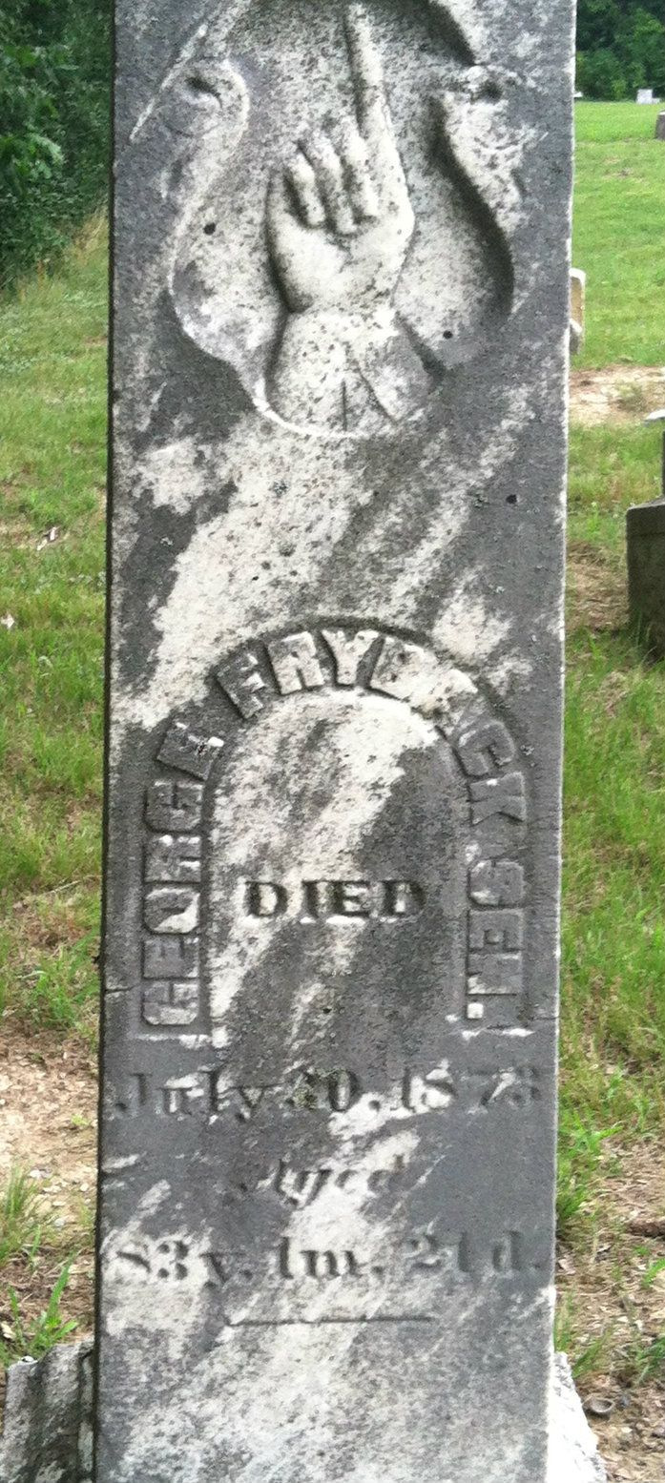

George T Fryback from tree Kennedy Family Tree
Birth 9 Jun 1790 Hampshire, West Virginia, USA
Marriage 30 Dec 1812 Montgomery, Ashland, Ohio, USA
Residence 1870 Ossian, Wells, Indiana, USA
Death 30 Jul 1875 Ossian, Wells, Indiana, USA
Father John Fryback (1752-1831)
Mother Lydia Emmerson (1760-1832)
Spouse Susannah Diehm (1791-1875)

