Franklin B. Fryback
October 21, 1862 – February 7, 1928

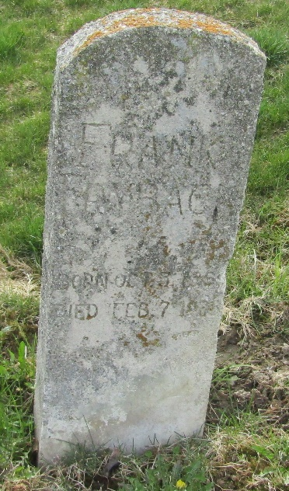

Franklin B. Fryback
in the Indiana, U.S., Death Certificates, 1899-2017
Name Franklin B. Fryback
Gender Male
Race White
Marital Status Married
Age 65
Birth Date 21 Oct 1862
Birth Place Uniondale, Indiana
Death Date 7 Feb 1928
Death Place Bluffton, Wells, Indiana, USA
Death Registration Date 1928
Father Lewis Fryback
Mother Elizabeth Hart
Spouse Fannie E. Bricker
Informant Charles Fryback; Bluffton, Indiana
Burial February 9, 1928; Murray Cemetery

