Eve (Schwartz) Fryback
1830 - 1888

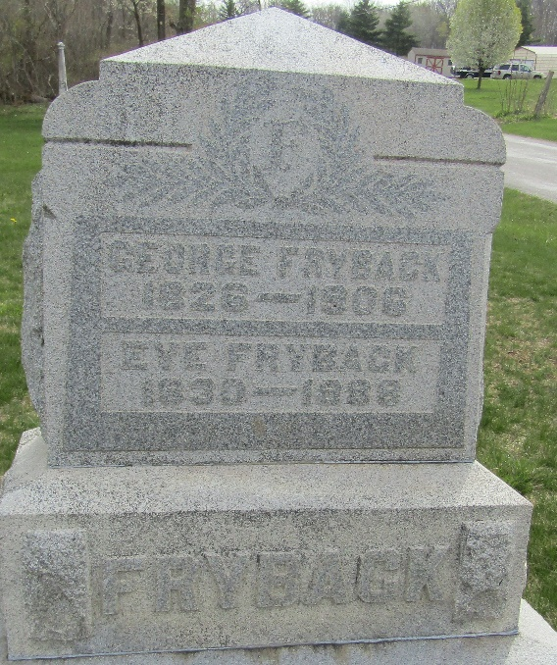

Eve Schwartz from tree Douglas E. Hart - Working Tree
Birth 1830 Pennsylvania, USA
Marriage 7 Jun 1849 Wells, Indiana, USA
Residence 1880 Wells, Indiana, USA
Death 1888 Ossian, Wells, Indiana, USA
Father Georg Schwartz (1792-1838)
Mother Sarah (1794-1850)
Spouse George T. Fryback (1826-1906)

