Lounie M. Fry
July 14, 1873 – January 14, 1888

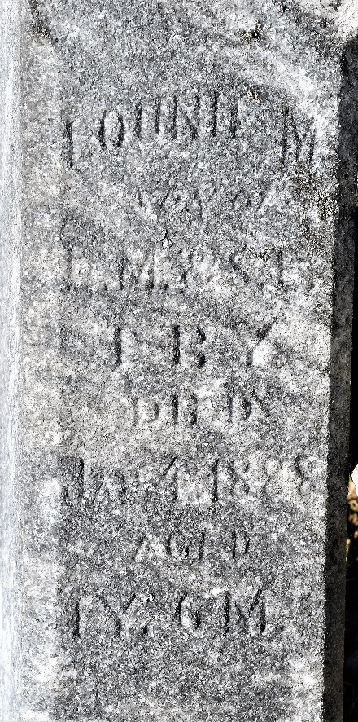

No further information found at this time

