Robert William Freeman
February 12, 1889 – April 24, 1965

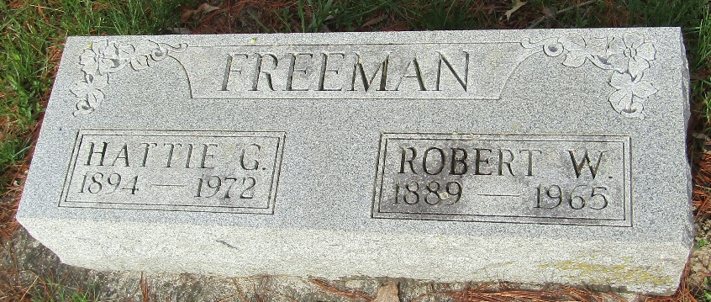

Robert William Freeman
in the Indiana, U.S., Death Certificates, 1899-2017
Name Robert William Freeman
Gender Male
Race White
Marital Status Married
Age 76
Birth Date 12 Feb 1889
Birth Place Indiana
Death Date 24 Apr 1965
Death Place Bluffton, Wells, Indiana, USA
Death Registration Date 1965
Father Elmer Freeman
Mother Elizabeth Clark
Informant Mrs. Robert W Freeman; wife; Bluffton, Indiana
Burial April 26, 1965; Murray Cemetery; Bluffton, Indiana

