Robert J. Freeman
August 16, 1923 – June 21, 2007

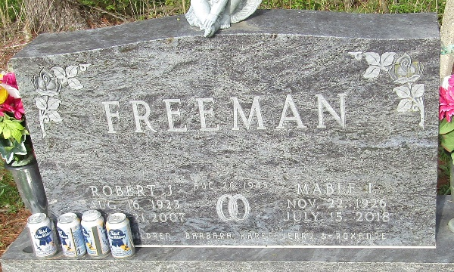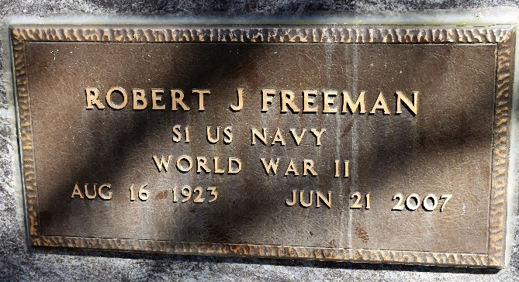

Robert J. Freeman, 83, of Murray died at 8:05 p.m. on Thursday, June 21, 2007 at Bluffton Regional Medical Center. He was born in Murray on Aug. 16, 1923, a son of W. Robert and Haddie (Gallamore) Freeman. He worked at Frantz Stone Co. for 30 years from 1956-1986. He was a World War II veteran of the U.S. Navy.
He was an avid stock car racer, and enjoyed Bluegrass music, flea markets, and camping. He was a member of the Moose Lodge, Eagles Lodge, Masonic Lodge #145, Scottish Rite, Elks Lodge, and American Legion.
He was married in Monroe on Aug. 26, 1945 to Mable L. Guntle, who survives. He is also survived by his son Jerry (Diane) Freeman of Yoder, his daughters Barbara (Richard) Crosbie of rural Poneto, Karen (Ron) Bell of Ft. Meyers, Fla., Roxanne (Arlin) Heyerly of Berne, along with 11 grandchildren and 15 great-grandchildren.
Visitation will be on Saturday from 2 to 8 p.m., and one hour prior to services on Sunday at Goodwin Memorial Chapel. Services are planned for 1:30 p.m. on Sunday at the funeral home with Doyle Frauhiger officiating. Burial will be in Murray Cemetery. American Legion Post #111 will be conducting graveside military honors.
Memorials may be made to Hospice of Northeast Indiana.

Bluffton News Banner, Wells County, Indiana
Saturday, June 23, 2007

