Mable L. (Guntle) Freeman
November 22, 1926 – July 15, 2018

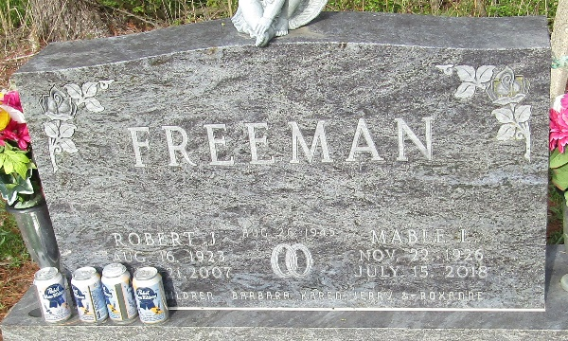

Mable L. Freeman, age 91, of Murray, passed away on Sunday, July 15, 2018, at Christian Care Retirement Community in Bluffton. Mable was born in Adams County Nov. 22, 1926, to Floyd and Dolly Springer Guntle. She married Robert J. Freeman in Monroe Aug. 26, 1945; he preceded her in death June 21, 2007.
A 1945 graduate of Monroe High School. Mable worked at Kitco for 27 years and volunteered at the Caylor Nickel Clinic in Bluffton since 2008. She was a member of the Bowling League in Bluffton and liked reading. Mable was an IU fan and loved playing euchre and bingo.
She loved to crochet, making 86 dolls over the years. Mable also enjoyed her time being a stock car racer. Mable was a member of The Women of the Moose, the Ladies Auxiliary American Legion Post 111, and Circle “W” Square Dance Group.
Mable is survived by one son, Jerry (Diane) Freeman of Yoder; three daughters, Mrs. Barbara (Richard) Crosby of Poneto, Mrs. Karen (Ron) Bell of Summerset, Ky., and Mrs. Roxanne (Arlin) Heyerly of Bluffton; 12 grandchildren; 19 great-grandchildren; several nieces and nephews; and her beloved dog, Sammie.
Mable was preceded in death by her parents; her husband; one sister, Gladys Harner; one granddaughter; and one grandson, Ryan Heyerly who passed away in 2003.
Visitation will be Wednesday, July 18, from 2 to 8 p.m. at Goodwin – Cale & Harnish Memorial Chapel in Bluffton. A funeral service will be held Thursday, July 19, at the funeral home at 10:30 a.m. Doyle Frauhiger will be officiating. Burial will follow at Murray Cemetery, in Wells County.
Memorial contributions may be made to Christian Care Retirement Community or Donor’s Choice.

Goodwin Funeral Home, Wells County, Indiana
July 16, 2018

