Infant Twins Freeman
March 2, 1922 – March 2, 1922

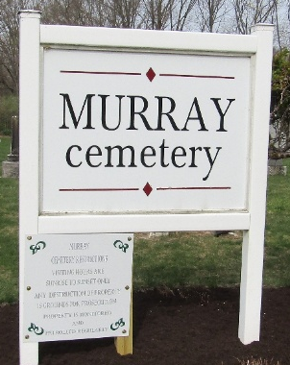

Infant Freeman Freeman
in the Indiana, U.S., Death Certificates, 1899-2017
Name Infant Freeman
Gender Male; Race White; Marital Status Single
Age 1 hour
Birth Date 2 Mar 1922
Birth Place Lancaster H Wells
Death Date 2 Mar 1922; premature
Death Place Lancaster, Wells, Indiana, USA
Death Registration Date 1922
Record # 11047
Father R W Freeman
Mother Hattie Gallimore
Informant R. W. Freeman; Bluffton, Indiana
Burial March 2, 1922; Murray Cemetery

**
Infant Freeman Freeman
in the Indiana, U.S., Death Certificates, 1899-2017
Name Infant Freeman
Gender Female; Race White; Marital Status Single
Age 1 hour
Birth Date 2 Mar 1922
Birth Place Lancaster H Wells
Death Date 2 Mar 1922; premature
Death Place Lancaster, Wells, Indiana, USA
Death Registration Date 1922
Record # 11048
Father R W Freeman
Mother Hattie Gallimore
Informant R. W. Freeman; Bluffton, Indiana
Burial March 2, 1922; Murray Cemetery

