Hattie G. (Gallimore) Freeman
November 16, 1894 – March 20, 1972

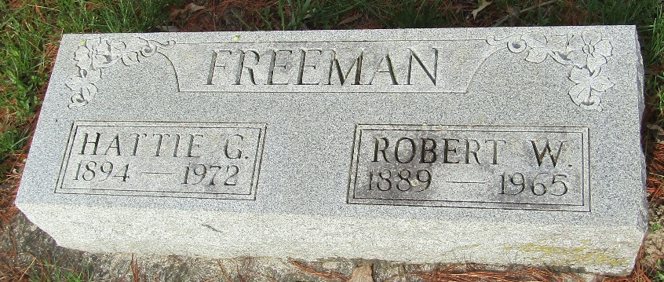

Mrs. Hattie Freeman, 77, of Robert W. Freeman, died Monday at Davis Rest Home. Born November 16, 1894 in Clinton County, she was a daughter of Frank and Dora Perkins Gallimore.
Her marriage to Mr. Freeman, who died April 24, 19656, took place May 4, 1912 at Tipton. She was a resident of Wells County since 1917 and was a member of the Murray Missionary Church.
Surviving are three daughters, Mrs. Dwight (Bernice) Clowser and Mrs. Metealea Inskeep, both of Fort Wayne and Mrs. Russel (Olive) Dalrymple of Warren and two sons, Robert, Jr. of Bluffton, Route 4, and Hershel of Uniondale. Two sisters, Mrs. Walter (Flossie) Freeman of Bluffton and Mrs. William (Zella) Gilliom of Bluffton, Route 4; a brother, Chester Gallimore, of Fort Wayne, 16 grandchildren also survive.
Services will be Thursday at the Goodwin Funeral Home with Rev. Leland Paul of Warsaw officiating; burial in the Murray Cemetery.

Wells County Indiana Obituaries
1969 – 1975

**
Indiana, Death Certificates, 1899-2011

Name: Hattie G Freeman
[Hattie G Gallimore]
Gender: Female
Race: White
Age: 77
Marital status: Widowed
Birth Date: 16 Nov 1894
Birth Place: Indiana
Death Date: 20 Mar 1972
Death Place: Bluffton, Wells, Indiana , USA
Father: Frank Gallimore
Mother: Dora Perkins
Informant: Robert Freeman; son; Bluffton, Ind.
Burial: March 23, 1972; Murray Cem., Bluffton, Ind.

