Flossie A. (Gallimore) Freeman
August 5, 1899 – September 5, 1997

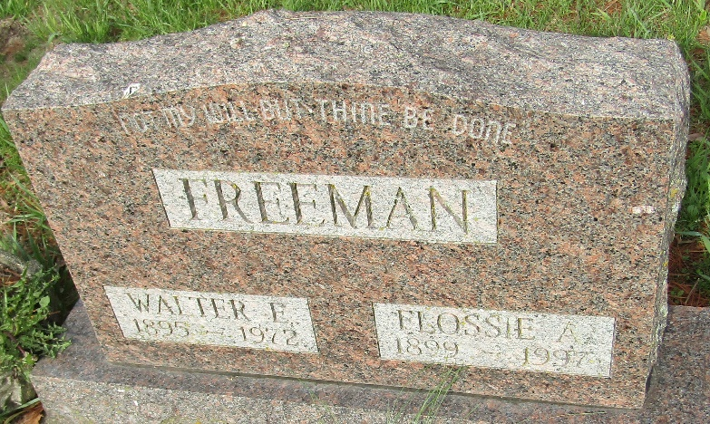

Flossie A. Freeman
in the Indiana, U.S., Death Certificates, 1899-2017
Name Flossie A. Freeman
[Flossie A. Gallimore]
Gender Female
Race White
Marital Status Widow
Age 98
Birth Date 5 Aug 1899
Birth Place Clinton, Co. Indiana
Death Date 5 Sep 1997
Death Place Bluffton, Wells, Indiana, USA
Death Registration Date 1997
Father Frank Gallimore
Mother Dona Perkins
Informant Diane Freeman; granddaughter; Ossian, Indiana
Burial September 8, 1997; Murray Cemetery; Murray, Indiana

