Donald F. Freeman
June 27, 1927 – February 26, 1984

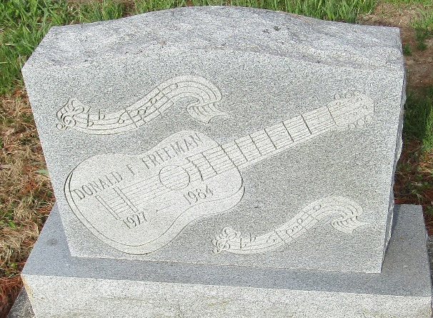

Donald F. Freeman
in the Indiana, U.S., Death Certificates, 1899-2017

Name Donald F. Freeman
Gender Male
Race White
Marital Status Married
Age 56
Birth Date 27 Jun 1927
Birth Place Indiana
Death Date 26 Feb 1984
Death Place Fort Wayne, Allen, Indiana, USA
Death Registration Date 1984
Father Walter Freeman
Mother Flossie Sallimore
Spouse Carolyn Grimes
Informant VA Medical Center records; Fort Wayne, Indiana
Burial March 3, 1984; Murray Cemetery; Markle, Indiana

