Louvina Adeline (Teeple) Fox
May 13, 1856 – July 8, 1884

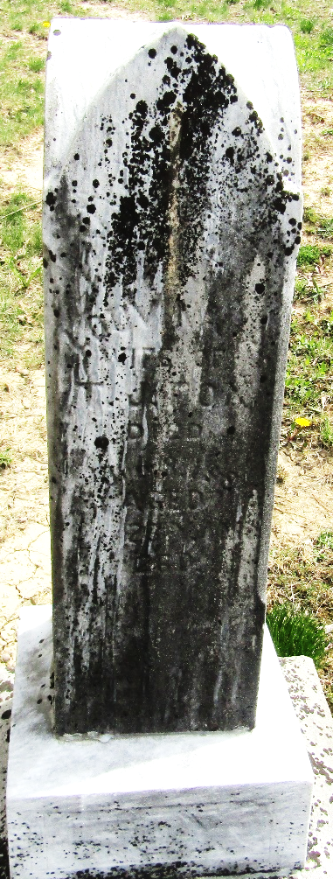

Lavina Adeline Teeple Fox from tree My Family Tree
Birth 1861 Iowa, USA
Residence 1870 Pleasant Mills, Adams, Indiana, USA
Marriage 6 Feb 1879 Wells, York, Maine, USA
Death 8 Jul 1884 Wells, Indiana, USA
Father Samuel Teeple (1825-1865)
Mother Laura Elizabeth Acker Teeple Wisehaupt (1830-1917)
Spouse Thomas J Fox (1855-1924)

