Lillian Lenore (Doty) Fox
September 1, 1869 – April 17, 1901

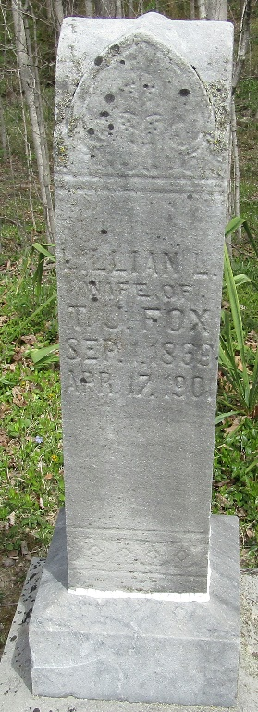

Lillion S Fox
in the Indiana, U.S., Death Certificates, 1899-2017
Name Lillion L. Fox
[Lillion L. Doty]
Gender Female
Race White
Marital Status Married
Age 31 years, 7 months, 16 days
Birth Date abt 1869
Birth Place Illinois
Death Date 17 Apr 1901; consumption
Death Place Bluffton, Wells, Indiana, USA
Death Registration Date 1901
Father Adam Doty
Mother Lily Meyers
Informant Thomas Fox; Bluffton, Indiana
Burial April 18, 1901; Murray, Indiana
**
Lillian Lenore Doty from tree jj Doty Family Tree
Record information.
Birth 1 Sep 1869 Fayette, Indiana, USA
Marriage 3 Sep 1885 Wells, Indiana, USA
Residence 1900 Wells, Indiana, USA
Death 17 Apr 1901 Bluffton, Wells, Indiana, USA
Record information.
Father Adam Doty (1846-1900)
Mother Lydia Jane Myers (1850-1932)
Spouse Thomas Jefferson Fox (1855-1924)

