Hope A. Fox
December 22, 1900 – April 28, 1901

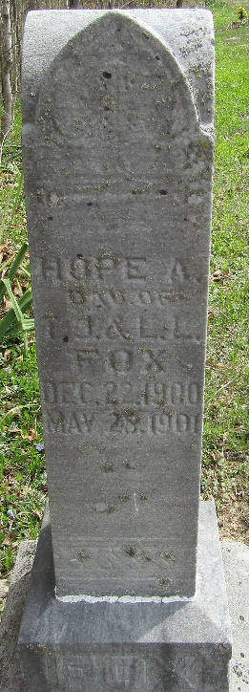

Hope A Fox
in the Indiana, U.S., Death Certificates, 1899-2017
Name Hope A Fox
Gender Male
Race White
Marital Status Single
Age 4 months, 7 days
Birth Date abt 1901
Birth Place Bluffton, Indiana
Death Date 28 Apr 1901
Death Place Bluffton, Wells, Indiana, USA
Death Registration Date 1901
Father Thomas Fox
Mother Lilian L. Doty
Informant Thomas Fox; Bluffton, Indiana
Burial April 29, 1901; Murry Cemetery

