Clay R. Fox
July 31, 1883 – May 15, 1884

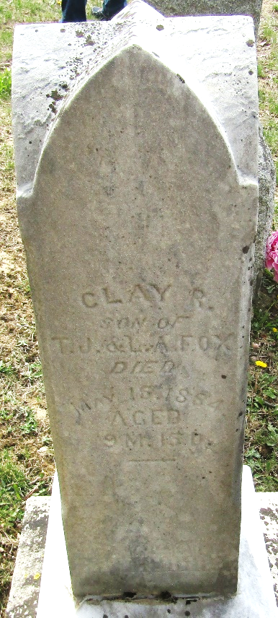

Clay R Fox from tree My Family Tree
Birth 31 Jul 1883 Wells, Indiana, USA
Death 15 May 1884 Wells, Indiana, USA
Father Thomas J Fox (1855-1924)
Mother Lavina Adeline Teeple Fox (1861-1884)

