Sarah Belle (Kirkpatrick) Fleming
November 29, 1821 – August 11, 1899

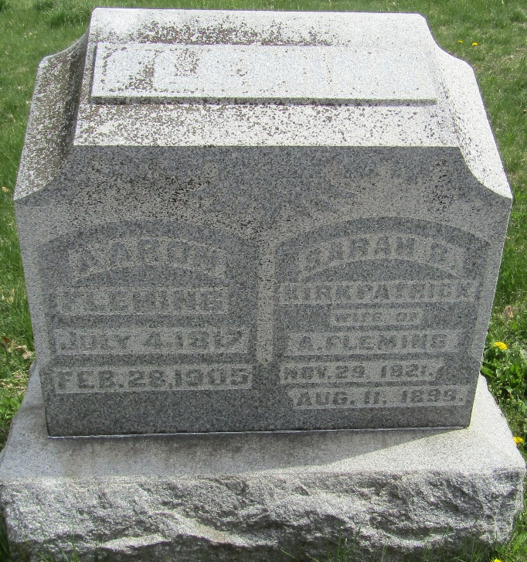

Sarah Belle Kirkpatrick from tree Harshman 2017
Birth 29 Nov 1821 Wayne, Wayne, Ohio, USA
Marriage 15 Sep 1842 Wayne, Monroe, Ohio, USA
Residence 1880 Wells, Indiana, USA
Death 11 Aug 1899 Bluffton, Wells, Indiana, USA
Father Daniel Kirkpatrick (1793-1858)
Mother Mary Johnston (1796-1858)
Spouse Aaron Fleming (1817-1905)

