Absalom Fleming
1783 – January 25, 1863

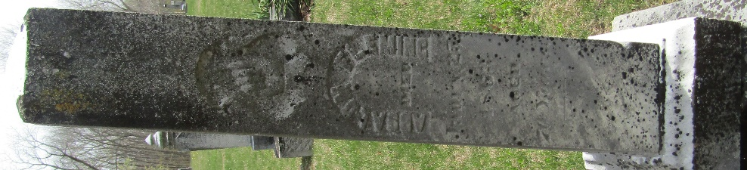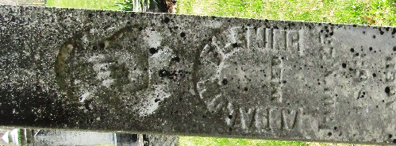

Absalom Fleming from tree bradycotton2014
Birth 1783 Delaware, USA
Marriage 10 Mar 1821 Harrison, Ohio, USA
Residence 1860 Wells, Indiana, USA
Death 25 Jan 1863 Wells, Indiana, USA
Father Alexander Fleming
Mother Ruth _____
Spouse Sarah B Wright (1802-1865)

