Aaron Fleming
July 4, 1817 – February 28, 1905

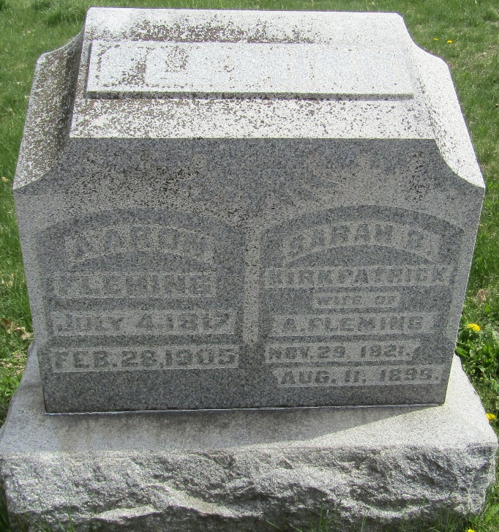

Aaron Fleming
in the Indiana, U.S., Death Certificates, 1899-2017
Name Aaron Fleming
Gender Male
Race White
Marital Status Widowed
Age 87
Birth Date 4 Jul 1817
Birth Place USA
Death Date 28 Feb 1905
Death Place Bluffton, Wells, Indiana, USA
Death Registration Date 1905
Father Absolom Fleming
Mother Wright
Spouse Sarah Kirkpatrick
Informant Harry Deam; Bluffton, Indiana
Burial March 3, 1905; Murray, Indiana

