Ephram Fisher
May 31, 1847 – September 10, 1872

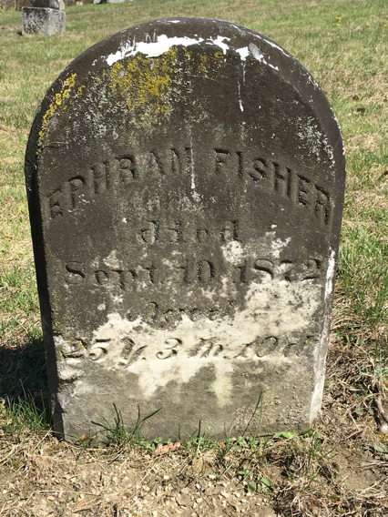

Ephraim Fisher from tree Bouslaugh Family Tree
Birth 31 May 1847 Pennsylvania, USA
Residence 1870 Wells, Indiana, USA
Death 10 Sep 1872
Father John W Fisher (1823-1906)
Mother Elizabeth Fares (Born 1821)

