Eliza (Reed) Fay
February 10, 1826 – November 25, 1911

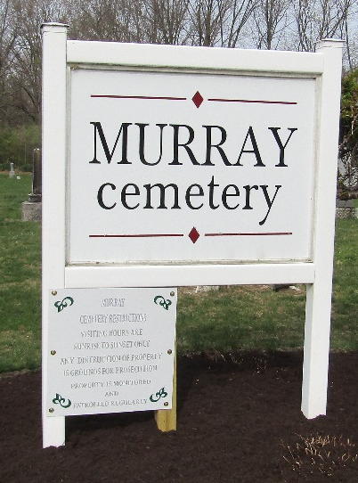

Eliza Fay
in the Indiana, U.S., Death Certificates, 1899-2017
Name Eliza Fay
[Eliza Reed]
Maiden Name Reed
Gender Female
Race White
Marital Status Widowed
Age 85
Birth Date 10 Feb 1826
Birth Place Pickaway Co. Ohio
Death Date 25 Nov 1911
Death Place Harrison, Wells, Indiana, USA
Death Registration Date 1911
Father Jacob Reed
Mother Nancy Rollins
Spouse Ezra Fay
Informant Fannie Burwell; Bluffton, Indiana
Burial November 26, 1911; Fairview Cemetery (sic)

