Raymond Monroe Fadley
April 23, 1903 – December 19, 1918

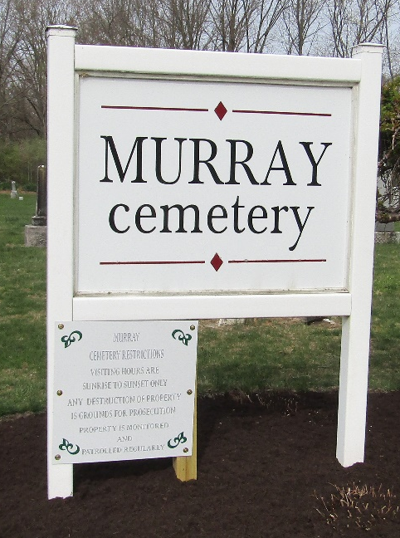

Raymond Monroe Fadley
in the Michigan, U.S., Death Records, 1867-1952
Name Raymond Monroe Fadley
Gender Male
Race White
Marital Status Single
Death Age 15
Birth Date 23 Apr 1903
Birth Place Bluffton Ind
Death Date 19 Dec 1918; accidental gun shot
Death Place Detroit, Wayne, Michigan, USA
Father Walter Fadley
Mother Sarah J Faust
Informant Len Monroe
Burial December 2, 1918; Bluffton, Indiana

