Theobold Essner, Jr.
May 18, 1825 – March 15, 1871

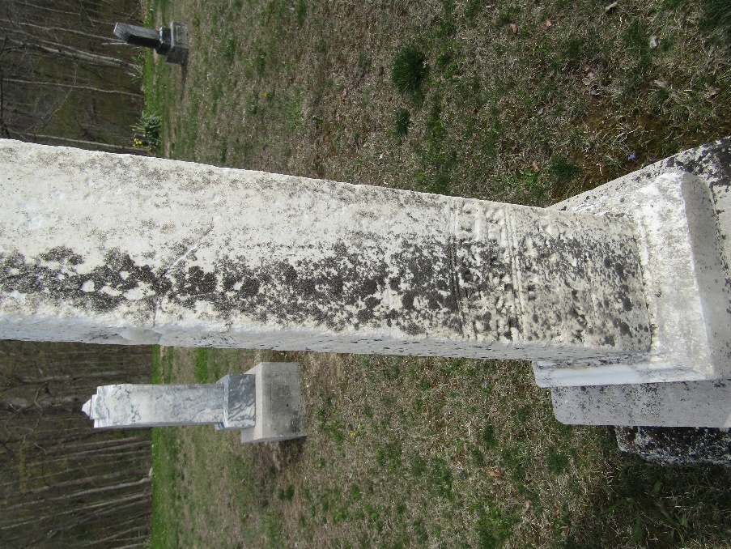

Theobold Jr. Essner from tree Jo McCallin Frank
Birth 18 May 1825 Bourbach-le-Bas, Haut-Rhin, France
Marriage 26 Jan 1853 Edgerton, Williams, Ohio, USA
Residence 1870 Wells, Indiana, USA
Death 15 Mar 1871 Wells, Indiana, USA
Father Theobold (Thiebaut) Essner (1792-1873)
Mother Maria Anna (Mariana) Nusbaum (1794-1890)
Spouse Ann Margaret Fisher (1833-1906)

