Ira Essner
1863 – March 16, 1867

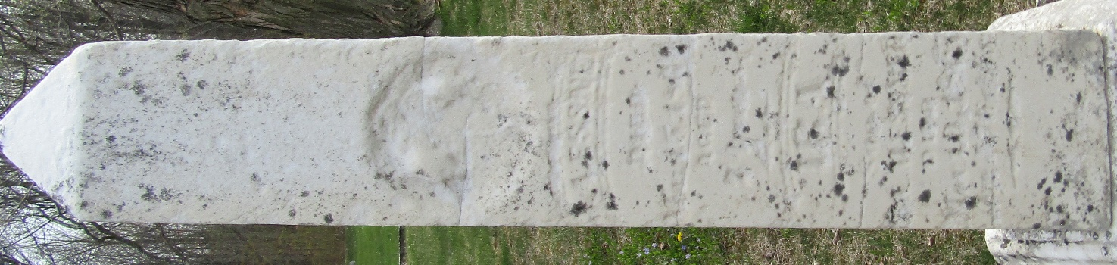

No further information found at this time

