Ann Margaret (Fisher) Essner
July 13, 1833 – March 21, 1906

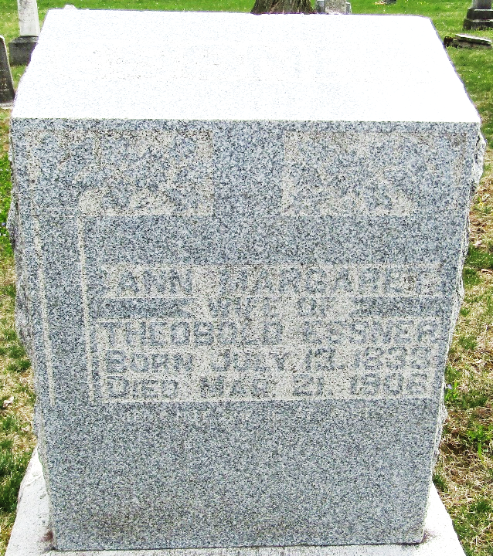

Ann Margaret Erdner
in the Indiana, U.S., Death Certificates, 1899-2017
Name Ann Margaret Essner
Gender Female
Race White
Marital Status Widowed
Age 72
Birth Date 13 Jul 1833
Birth Place Bavaria, Germany
Death Date 21 Mar 1906
Death Place Bluffton, Wells, Indiana, USA
Death Registration Date 1906
Father Jacob A Fisher
Mother Barbara Houk
Informant Geo. Fisher; Edgerton, Ohio
Burial March 23, 1906; Murray Cemetery

