Virgil Vernon Edington
February 25, 1906 – February 1, 1910

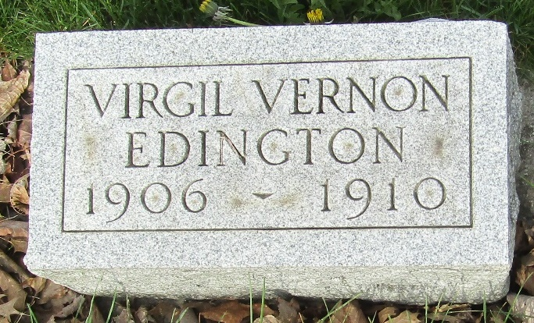

Argel V Edington
in the Indiana, U.S., Death Certificates, 1899-2017
Name Virgel V Edington
Gender Male
Race White
Marital Status Single
Age 4
Birth Date 25 Feb 1906
Birth Place Indiana
Death Date 1 Feb 1910
Death Place Jackson, Huntington, Indiana, USA
Death Registration Date 1910
Father Charles Edington
Mother Minnie Hege
Informant C. T. Edington; Roanoke, Indiana
Burial February 3, 1910; Murray Cemetery

