Sarah Jane (Lash) Edington
May 4, 1846 – October 29, 1927

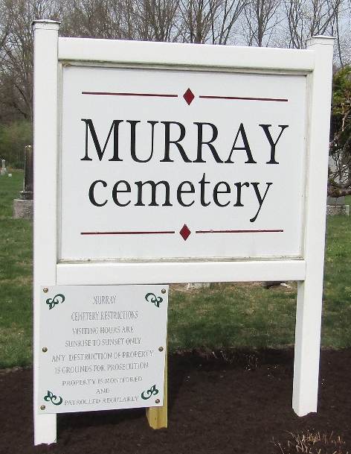

Sarah Jane Edington
in the Michigan, U.S., Death Records, 1867-1952
Name Sarah Jane Edington
[Sarah Jane Lash]
Gender Female
Race White
Marital Status Widowed
Death Age 81
Birth Date 4 May 1846
Birth Place Green County, Indiana
Death Date 29 Oct 1927
Death Place Detroit, Wayne, Michigan, USA
Father Issac Lash
Mother Matilda Shrauntz
Informant Mrs. Faust; daughter
Burial October 31, 1927; Bluffton, Wells County, Indiana
File Number 089340

