Minnie Bell (Hege) Edington
May 29, 1883 – May 25, 1966

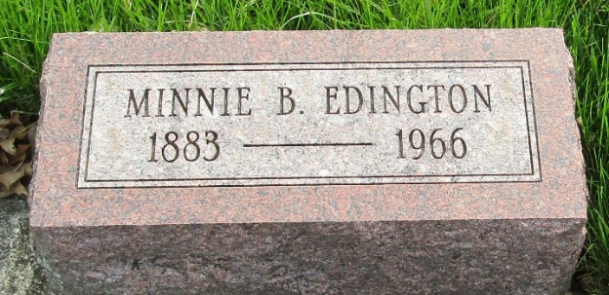

Minnie Bell Edington
in the Indiana, U.S., Death Certificates, 1899-2017
Name Minnie Bell Edington
[Minnie Bell Hege]
Gender Female
Race White
Marital Status Widowed
Age 82
Birth Date 29 May 1883
Birth Place Wells County, Indiana
Death Date 25 May 1966
Death Place Huntington, Huntington, Indiana, USA
Death Registration Date 1966
Father Amos Hege
Mother Unknown
Informant William Edington; son; Huntington, Indiana
Burial May 28, 1966; Murray Cemetery; Wells County, Indiana

**
Minnie Bell Edington from Morecraft Family Tree
Spouse Charles Thomas Edington
Father Amos L. Hege
Mother Mary Elizabeth Patten
Children William Wayne "Red"
Birth 29 May 1883 Wells, Indiana, USA
Death 25 May 1966 Huntington, Huntington, Indiana, USA
Residence 1940 Huntington, Indiana, US

