Marian Edington
November 12, 1867 - October 2, 1868

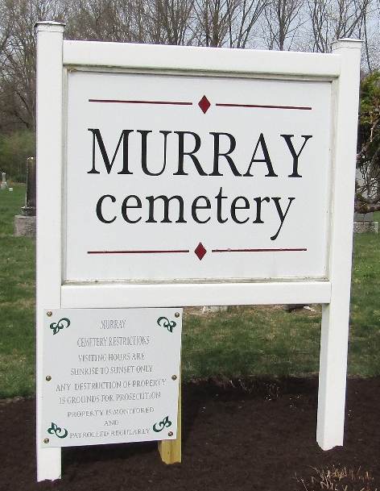

Marian Edington from tree Wilson & Cravens
Birth Wells, Indiana, USA
Death 2 Oct 1868 Wells, Indiana, USA
Father John C Edington (1807-1865)
Mother Elizabeth Noggle (1816-1890)

