John Edington
January 18, 1833 – August 13, 1907

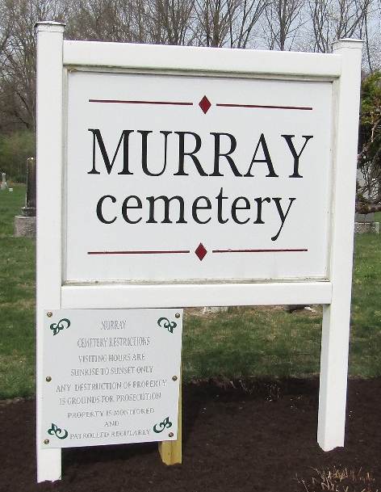

John Eddington
in the Indiana, U.S., Death Certificates, 1899-2017
Name John Eddington
Gender Male
Race White
Marital Status Widowed
Age 74
Birth Date 18 Jan 1833
Birth Place Ohio
Death Date 13 Aug 1907
Death Place Bluffton, Wells, Indiana, USA
Death Registration Date 1907
Father Philip Eddington
Mother Catherine Nagal
Spouse Sarah Lask
Informant Mary Fauste; Bluffton, Indiana
Burial August 15, 1907; Murray Cemetery

