Forest Mason Edington
September 3, 1876 – May 4, 1931

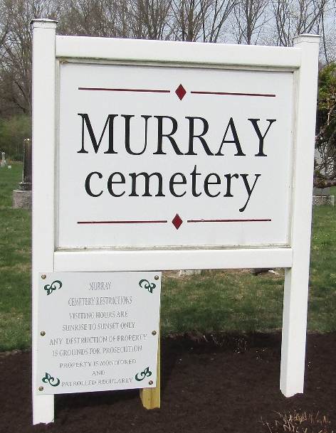

Forest Mason Edington
in the Indiana, U.S., Death Certificates, 1899-2017
Name Forest Mason Edington
Gender Male
Race White
Marital Status Single
Age 54
Birth Date 3 Sep 1876
Birth Place Lancaster Trop Wells Co., Indiana
Death Date 4 May 1931
Death Place Bluffton, Wells, Indiana, USA
Death Registration Date 1931
Father William Edington
Mother Elizabeth Bender
Informant Mrs. Alice Sands; Bluffton, Indiana
Burial May 6, 1931; Murray Cemetery

