Elizabeth (Bender) Edington
November 18, 1840 – April 12, 1894

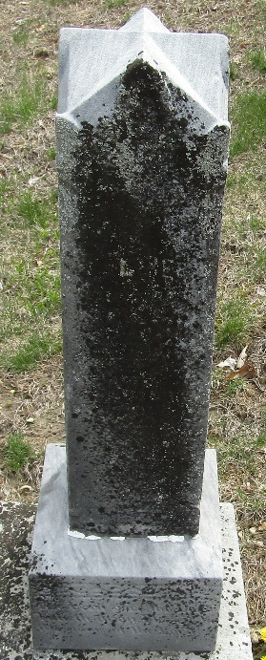

Elizabeth (Bender) Edington was born November 18th, 1840, in Tuscarawas County, Ohio. Died in Wells County, Indiana April the 12th, 1894. She was united in marriage to William Edington, August 30th, 1860.
There was born to them nine children, two of whom died in infancy, and her husband preceded her to the better world in the year 1881.
She united with the Methodist Church when quite young and afterward joined the United Brethren with her husband and remained a devoted Christian until death. She was 53 years, 3 months and 24 days. Her last words were, "God take me home."
Her funeral occurred last Friday at Murray, conducted by her pastor, Rev. D. W. Abbott.

Bluffton Banner; Wells County, Indiana
Wednesday, April 18, 1894
**
Indiana, U.S., WPA Death Index, 1882-1920
Name Elizabeth Edington
Date Apr 12, 1894
Location Wells County
Age 50 Yr
Gender Female
Race White
Source location County Health Office, Bluffton
Source notes The source of this record is the book H-14 on page 74 within the series produced by the Indiana Works Progress Administration.
**
Elizabeth Bender Edington from tree Mazza Family Tree
Birth 18 Nov 1840 Lawrence, Tuscarawas, Ohio, USA
Marriage 30 Aug 1860 Bluffton, Wells, Indiana, USA
Residence 1880 Wells, Indiana, USA
Death 12 Apr 1894 Bluffton, Wells, Indiana, USA
Father Jesse Bender (1812-1871)
Mother Catherine Lash (1816-1893)
Spouse William Wallace Edington (1837-1881)

