Elizabeth Alice Edington
March 7, 1857 – November 7, 1862

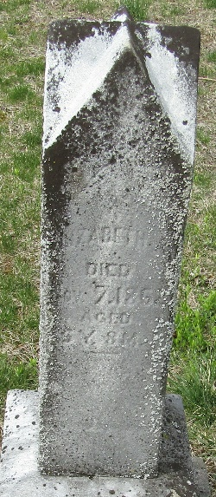

Elizabeth Alice Edington from tree STARR and HOLLOWAY Families

Birth 7 Mar 1857 Wells, Indiana, USA
Residence 1860 Wells, Indiana, USA
Death 7 Nov 1862 Wells, Indiana, USA
Father John Calvin Edington (1807-1865)
Mother Elizabeth Noggle (1816-1890)

