Charles Thomas Edington
June 28, 1875 – February 28, 1940

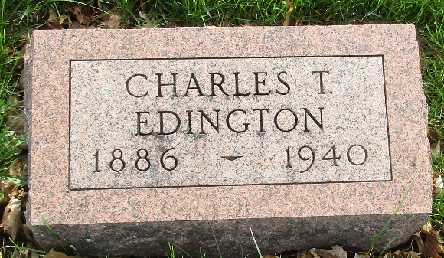

Charles Thomas Edington, aged 64, died at 1:45 am Wednesday at his home, three and half miles south of the city on the Lancaster Road following an illness of four years. He had been seriously ill two weeks.
Mr. Edington was born June 28, 1875 in Wells County to John and Sarah Lash Edington and was married to Minnie Hege September 26, 1899.
Surviving is the widow, five children, Mrs. William Orr and Dale Edington, both of this city; Everett Edington and Billy Wayne Edington, both of Lancaster Township; and Mrs. Russell Malcolm, Fort Wayne; a sister, Mrs. Mary Foust, Detroit, Michigan; three brothers, Calvin Edington, Fort Wayne, Robert Edington, Waterloo, Indiana and Colson Edington, Bluffton; five grandchildren and three great grandchildren.
A son, Virgil Edington and a sister, Mrs. Dora Faylor, preceded him in death.
He was a member of the Murray Christian Church and of the Masonic Lodge at Roanoke.
The body was taken to the Bailey Funeral Home where funeral services will be conducted at 2 pm Friday with the Rev. John Paul Pack officiating. The Masons will be in charge of the rites. Burial will be in the Murray Cemetery.

Herald Press, Huntington County, Indiana
Thursday, February 29, 1940

**

Indiana, U.S., Death Certificates, 1899-2017
Name Charles Thomas Edington
Gender Male; Race White
Marital Status Married
Age 64
Birth Date 28 Jun 1875
Birth Place Wells County, Indiana
Death Date 28 Feb 1940
Death Place Huntington, Huntington, Indiana, USA
Death Registration Date 1940
Father John Edington
Mother Sarah Lash
Spouse Minnie
Informant Mrs. Minnie Edington; Huntington, Indiana
Burial March 1, 1940; Murray Cemetery; Wells County, Indiana

**
Indiana, U.S., Marriage Index, 1800-1941

Name Charles Eddington
Marriage Date 26 Sep 1899
Marriage Place Wells, Indiana, USA
Spouse Name Minnie Hege

**
U.S., World War I Draft Registration Cards, 1917-1918

Name Charles Thomas Edington
Race White
Birth Date 28 Jun 1875
Residence Date 1917-1918
Residence Place Huntington County, Indiana, USA
Physical Build Medium; Height Medium
Hair Color Dark Brown; Eye Color Gray
Spouse Minnie Edington

