Matilda Jane (McAfee) Earl
September 1, 1848 – September 8, 1902

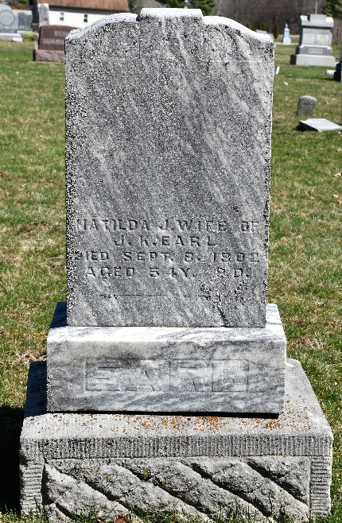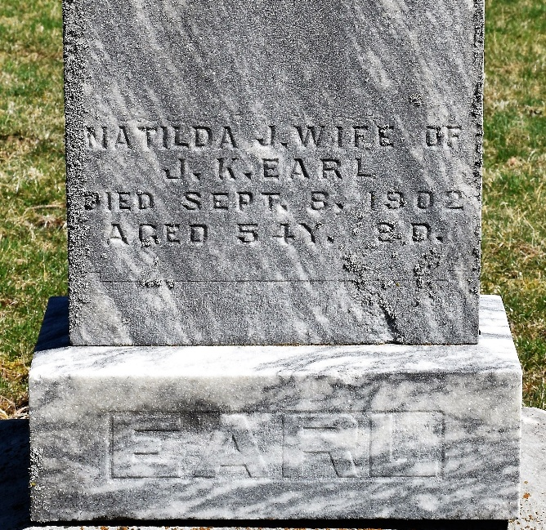
Photos by Colleen Sanders Broyles

Matilda Jane Earl
in the Indiana, U.S., Death Certificates, 1899-2017
Name Matilda Jane Earl
Gender Female
Race White
Marital Status Married
Age 54
Birth Date 1 Sep 1848
Birth Place Wayne County, Ohio
Death Date 8 Sep 1902
Death Place Murray, Wells, Indiana, USA
Death Registration Date 1902
Father James Mc Affee
Mother Eliza Cherry
Spouse James Earl
Informant James Earl; Bluffton, Indiana
Burial September 9, 1902; Murray Cemetery

