Eleanor (Sowards) Dowty
April 16, 1829 – January 29, 1901

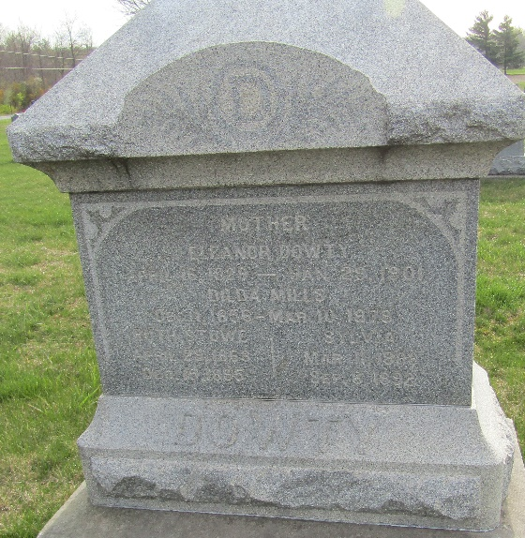

Elener Dowty
in the Indiana, U.S., Death Certificates, 1899-2017
Name Elener Dowty
[Elener Sowards]
Gender Female
Race White
Marital Status Widow
Age 71 years, 9 months, 13 days
Birth Date abt 1830
Birth Place Ohio
Death Date 29 Jan 1901
Death Place Ossian, Wells, Indiana, USA
Death Registration Date 1901
Father Rubert Sowards
Mother Matisha McKinney
Informant Wm. Sowards; Tocsin, Indiana
Informant January 31, 1901; Murray Cemetery

