William Wilson Donaldson
November 12, 1856 – May 19, 1857

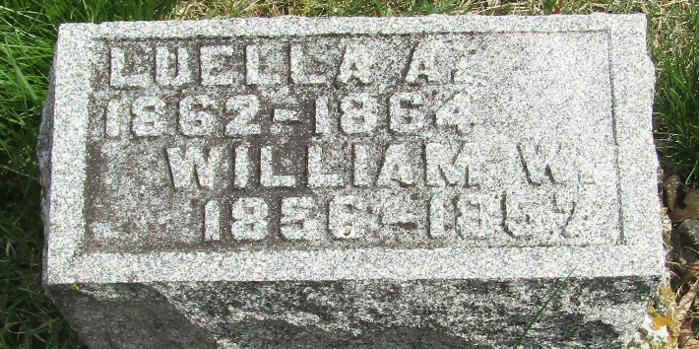

William Wilson Donaldson from tree Guthrie Family Tree
Birth 12 Nov 1856 Wells, Indiana, USA
Death 19 May 1857 Wells, Indiana, USA
Father William Alexander Donaldson (1833-1918)
Mother Eliza Jane Karns (1834-1921)

