William Alexander Donaldson
August 19, 1833 – July 26, 1918

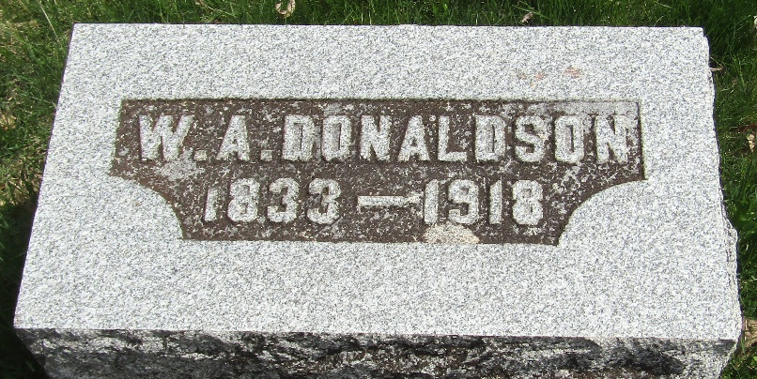

W. Alexander Donalson
in the Indiana, U.S., Death Certificates, 1899-2017
Name W. Alexander Donaldson
Gender Male
Race White
Marital Status Married
Age 84
Birth Date 19 Aug 1833
Birth Place Pennsylvania
Death Date 26 Jul 1918
Death Place Bluffton, Wells, Indiana, USA
Death Registration Date 1918
Father Robert Donaldson
Mother Anna Felton
Spouse Eliza Jane Karnes
Informant Family; Bluffton, Indiana
Burial July 29, 1918; Murray Cemetery

