Samuel F. Donaldson
June 20, 1867 – November 13, 1887

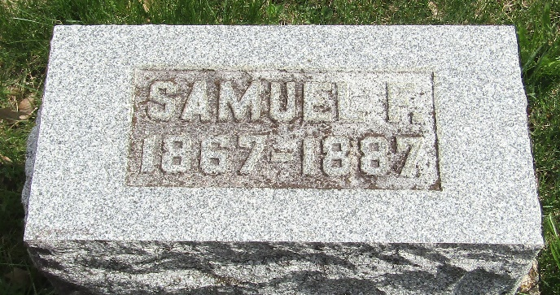

Samuel F. Donaldson from tree McCune/Muhs Family Tree
Birth 20 Jun 1867 Wells, Indiana, USA
Residence 1880 Wells, Indiana, USA
Marriage 11 Mar 1884 Benton, Ringgold, Iowa, USA
Death 13 Nov 1887
Father William Alexander Donaldson (1833-1918)
Mother Eliza Jane karue Karns Donaldson (1834-1921)
Spouse Bessie Ida Ward (Born 1863)

