Luella A. Donaldson
December 22, 1862 – January 9, 1864

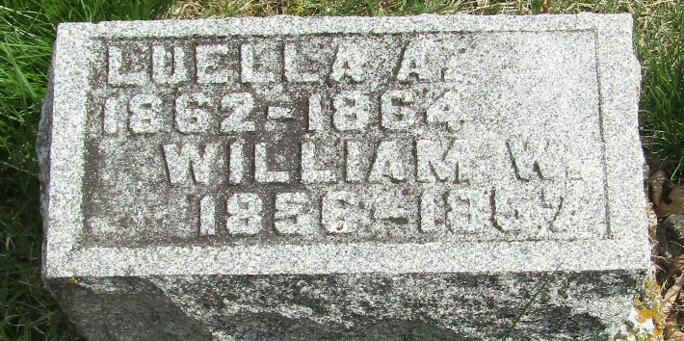

Luella A. Donaldson from tree Guthrie Family Tree
Birth 22 Dec 1862 Wells, Indiana, USA
Death 9 Jan 1864 Wells, Indiana, USA
Father William Alexander Donaldson (1833-1918)
Mother Eliza Jane Karns (1834-1921)

