Jane Donaldson
February 26, 1794 – June 9, 1854

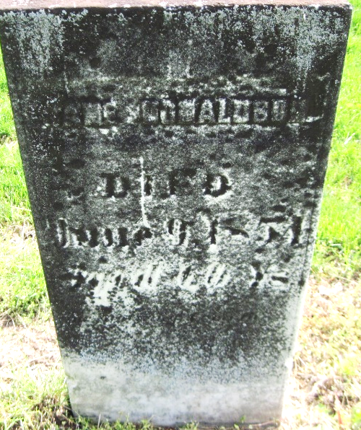

Jane Donaldson from tree Donaldson Family Tree
Birth 26 Feb 1794 Derry, Dauphin, Pennsylvania, USA
Death 9 Jun 1854
Father Isaac Donaldson (1770-1832)
Mother Elizabeth McClatchey (1769-1808)
1025 People 2 Records 4 Sources

