James W. Donaldson
February 9, 1827 – February 9, 1857

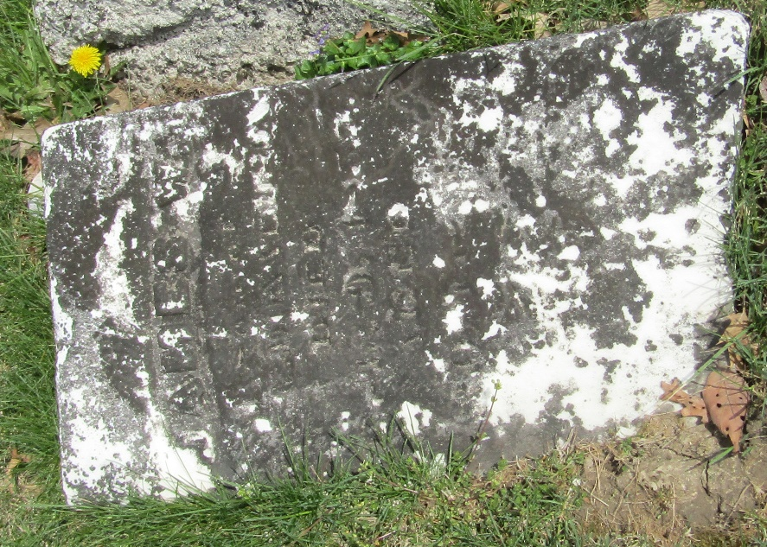

James W Donaldson from tree Angela S Brown
Birth 9 Feb 1827 Ligonier, Westmoreland, Pennsylvania, USA
Residence 1850 Wells, Indiana, USA
Marriage 16 Apr 1851 Appanoose, Iowa, USA
Death 9 Feb 1857 Madison, Jefferson, Indiana, USA
Father Robert Donaldson (1800-1880)
Mother Ann Felton (1806-1861)
Spouse Elizabeth Wilson (1832-1913)

