Infant Donaldson
September 22, 1906 – October 22, 1906

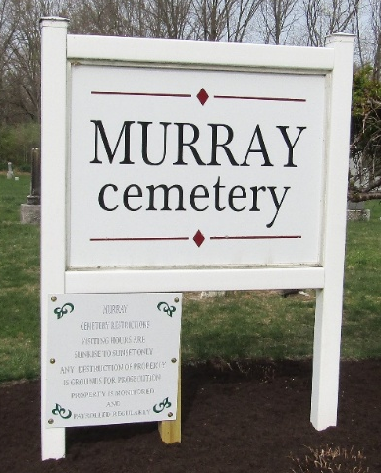

The home of Mr. and Mrs. Lewis Donaldson was saddened this morning by the death of their four-weeks-old son, who died this morning at six o'clock. The baby had never been well, suffering almost since birth with bowel and stomach complaint and there was never much hope of its recovery. The child was born four weeks ago Saturday.
The funeral will be held at the residence at two o'clock tomorrow afternoon, Rev. McMurray being in charge and interment will take place at the Murray Cemetery.

Evening News; Bluffton, Indiana
October 22, 1906
**
Indiana, U.S., Death Certificates, 1899-2017
Name Infant Danelson
Gender Male
Race White
Marital Status Single
Age 1 month
Birth Date 22 Sep 1906
Birth Place Wells County, Indiana
Death Date 22 Oct 1906
Death Place Bluffton, Wells, Indiana, USA
Death Registration Date 1906
Father Lewis Danelson
Mother Mary Straw
Informant Lewis Danelson; Bluffton, Indiana
Burial October 24, 1906; Murray Cemetery

