Eliza Jane (Karns)Donaldson
December 25, 1834 – April 19, 1921

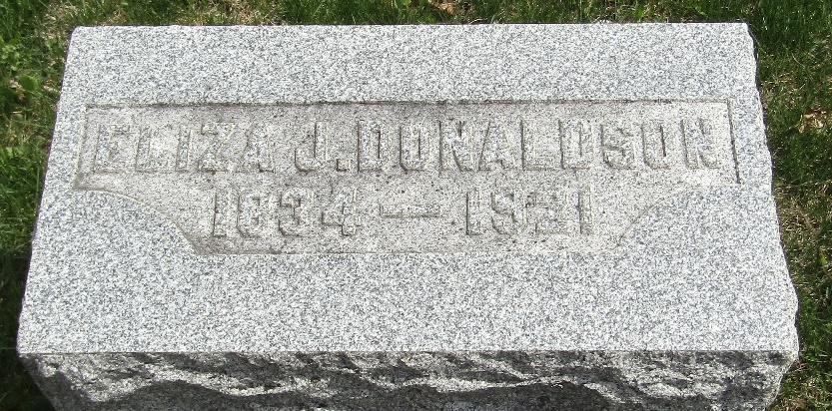

Eliza Jane Donaldon
in the Indiana, U.S., Death Certificates, 1899-2017
Name Eliza Jane Donaldon
[Eliza Jane Kanis]
Maiden Name Donaldson
Gender Female
Race White
Marital Status Widow
Age 86
Birth Date 25 Dec 1834
Birth Place Ohio
Death Date 19 Apr 1921
Death Place Bluffton, Wells, Indiana, USA
Death Registration Date 1921
Father Michael Karns
Mother Martha M
Spouse W. A. Donaldson
Informant Alexander Brickley; Bluffton, Indiana
Burial April 21, 1921; Murray Cemetery

