Ann M. (Felton) Donaldson
February 9, 1806 – August 1, 1861

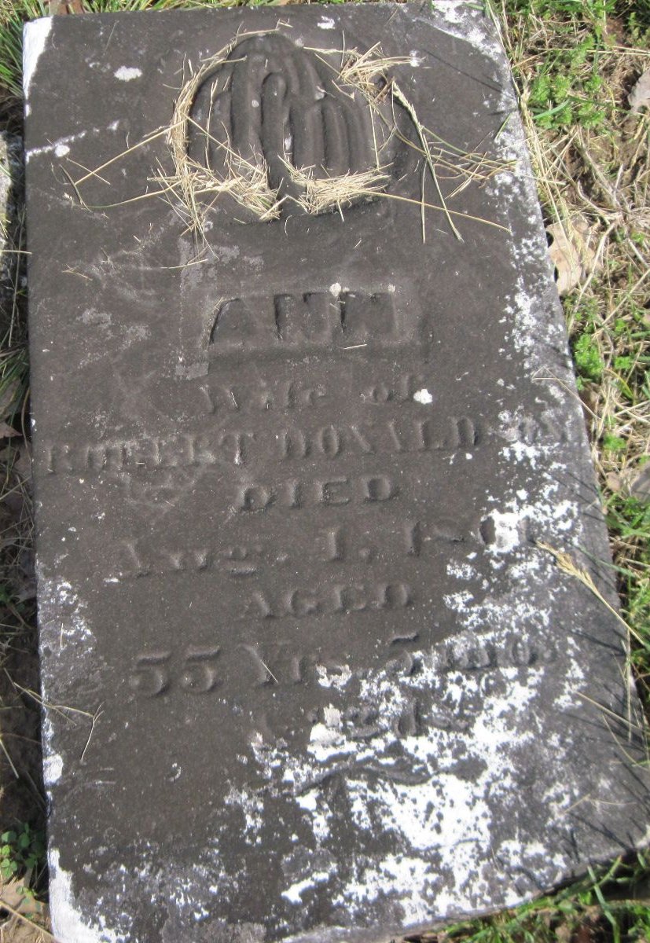

Ann Felton from tree ISTVAN~1.GED 13 July 2020
Birth 9 Feb 1806 Frankstown, Blair, Pennsylvania, USA
Marriage 14 Mar 1826
Residence 1860 Wells, Indiana, USA
Death 1 Aug 1861 Indiana, USA
Father Robert Felton (Born 1775)
Mother Sarah Katie McCutcheon (1778-1822)
Spouse Robert Donaldson (1800-1879)

