William Dishong
1803 – June 11, 1896

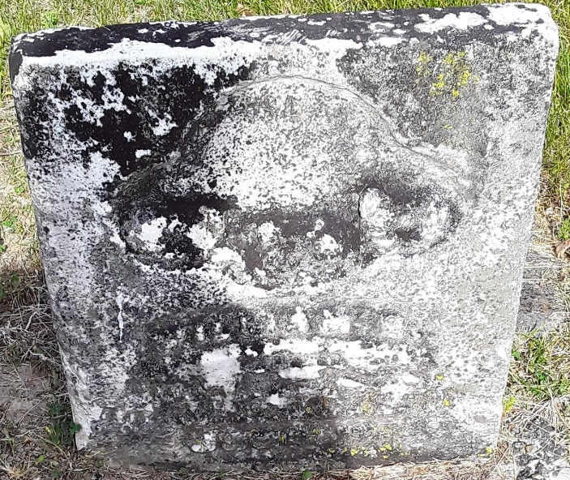

William Dishong from tree Williams-Kerlin Family Tree
Birth 1803 Bedford, Bedford, Pennsylvania, USA
Marriage 6 Apr 1869 Wells, Indiana, USA
Residence 1880 Wells, Indiana, USA
Death 11 Jun 1896 Wells, Indiana, USA
Father Johann Balthasar "Baltis" Balsar Dishong Deshon (1747-1833)
Mother Marie Elisabeth Edelman (1766-1835)
Spouse Elizabeth Kline (1818-1866)
Spouse Nancy Jane Jarvis (Born 1845)

