Sarah Emeline Dishong
January 5, 1899 – December 24, 1908

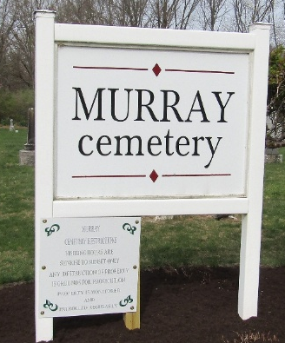

WIDOW'S DAUGHTER BURNED TO DEATH
Emma Dishong's Dress Caught from Stove and She Lived Only Few Hours

The horrible death which befell Emma Dishong, little nine-year-old daughter of Mrs. Elijah Dishong, a widow living at Kingsland, six miles north of Bluffton, has brought deepest gloom and sadness not only to the family, but to the entire community and there will be but little Christmas cheer in that neighborhood because of the terrible accident which resulted in the child being almost literally burned alive. While popping corn at her home about one o'clock Thursday afternoon, her dress caught fire from the stove and burned almost to a crisp, dying at nine o'clock at night.
With the little girl in the house when she caught fire, was only a little niece, a five-year-old daughter of Alonzo Kahn, son-in-law of Mrs. Dishong. As nearly as could be learned from little Emma after the accident, she had opened the door to the heating stove and was holding a short-handled corn popper over the blaze by holding the popper through the door. Either from the hot stove or from flames leaping through the door, her dress caught fire, and she ran screaming into the yard, attracting neighbors by her cries. The first to reach her was a brother, a little older than herself, and this child burned his hands badly in the endeavors to smother out the fire from his sister's clothing. Next to reach the burning child was her brother-in-law, Lon Kahn, and he also tried in vain to smother out the fire, and only extinguished the flames by pouring over her an entire bucket of water with which her little brother arrived with a few minutes after Mr. Kahn reached her.
The little girl had run about forty feet into the yard and after smothering out the fire, Mr. Kahn picked her up into his arms and carried her into the house and dispatched word to the child's mother, brothers and sisters, of the awful accident. Mrs. Dishong had gone to the Oliver home northwest of Kingsland to do a job of (cut off)
Bluffton Chronicle, Wells County, Indiana
Wednesday, December 30, 1908

**
Indiana, U.S., Death Certificates, 1899-2017
Name Sarah Emeline Dishong
Gender Female
Race White
Age 9
Birth Date 5 Jan 1899
Birth Place Indiana
Death Date 24 Dec 1908
Death Place Kingsland, Wells, Indiana, USA
Death Registration Date 1908
Father Elijah Dishong
Mother Elizabeth
Informant Mrs. Dishong; Kingsland, Indiana
Burial December 25, 1908; Murray Cemetery

