John Dishong
May 17, 1855 – July 5, 1929

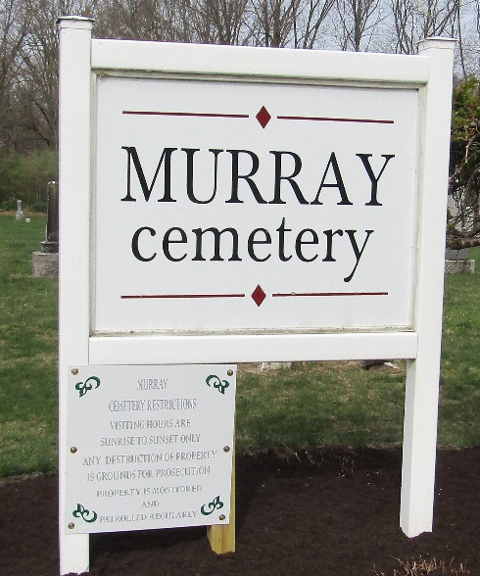

Joline Dishoug
in the Indiana, U.S., Death Certificates, 1899-2017
Name John Dishong
Gender Male
Race White
Marital Status Single
Age 75
Birth Date 17 May 1855
Birth Place Wells County, Indiana
Death Date 5 Jul 1929
Death Place Harrrison, Wells, Indiana, USA
Death Registration Date 1929
Father William Dishoug
Mother Elizabeth
Informant Albert Millington; Bluffton, Indiana
Burial July 6, 1929; Murray Cemetery

