Elizabeth (Cline) Dishong
November 5, 1815 – October 29, 1866

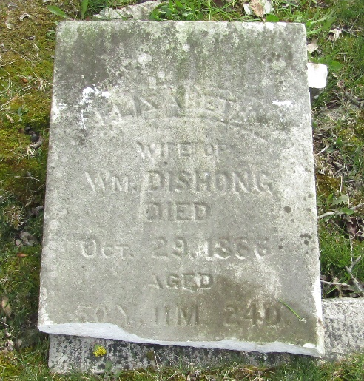

Elizabeth Cline from tree Williams-Kerlin Family Tree
Birth 5 Nov 1815 Belfast, Fulton, Pennsylvania, USA
Marriage 1840 Pennsylvania, USA
Residence 1860 Wells, Indiana, USA
Death 29 Oct 1866 Wells, Indiana, USA
Father Henry Cline (1760-1831)
Mother Mary Dishong (1775-1850)
Spouse William Dishong (1803-1896)

